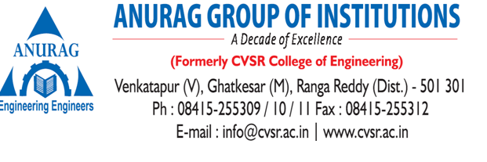

**Department of Information Technology**

Professional development and career-building opportunities are the main focus of the Professional chapters at Department of Information Technology.

**Various Professional Chapters at Department Level are:**

* Computer Society of India
* Institute of Electrical and Electronics Engineers
* Indian Society for Technical Education
* Association Computation Machinery.

**Benefits of Participating at various Professional Societies events are:**

* Networking with other industrial engineering professionals

## Developing Leadership Skills

## Continuing Education and

* Reducing the Gap between Industry and Institute.

**Objectives of professional Chapters**:

* **ISTE** aims at improving the standard of Technical Education in India.
* **IEEE** is the world’s largest professional association dedicated to advancing technological innovation and excellence for the benefit of humanity.
* **CSI** has been instrumental in guiding the Indian IT industry down the right path.
* **ACM** foster an involvement in the awareness of the development of the general computing environment.

**Events conducted under various Professional Chapters:**

|  |  |  |  |  |
| --- | --- | --- | --- | --- |
| **S. No.** | **Name of the Workshop/ Seminar** | **Resource Person** | **Student Chapter Name** | **Dates** |
| 1 | Python Programming | Mr. P. Karthik, TASK | CSI | 3.3.2020 to 7.3.2020 |
| 2 | Database Programming with SQL | Mr. P. Vamshidhar Reddy, TASK | CSI | 10.12.2.19 to 12.12.2019 |
| 3 | soft skills | Mr. E. Indra Kumar | IEEE | 6.12.2019 to 7.12.2019 |
| 4 | Virtual Reality & Augmented Reality | Mr. Saurav Bandi, Archmaze | CSI | 06.07.2019 |
| 5 | Google Android Development | Mr. P. Arun Reddy, TASK | IEEE | 25.06.2019 to 29.06.2019 |
| 6 | Artificial Intelligence | Mr. Jayendra Vadrevu | CSI | 16.03.2019 |
| 7 | Google Android Development | Mr. P. Arun Reddy, TASK | IEEE | 12.11.2018 to 16.11.2018 |
| 8 | Oracle Java Programming | Mr. Ramesh Korivi, TASK | CSI | 04.08.2018 to 8.08.2018 |
| 9 | 2-day workshop on “Personal Skills” | Mr. Benson cheripelli, TASK | ISTE | 27.07.2018 to 28.07.2018 |
| 10 | Testing Tools | Mr. Veera Nagesh, Ebix software pvt. Ltd | IEEE | 28.07.2018 |